CSE446/598
Hypermedia Services Assignment
Program Design
Shihuan Shao
1.
a. HTTP Request mapping for Appeal process

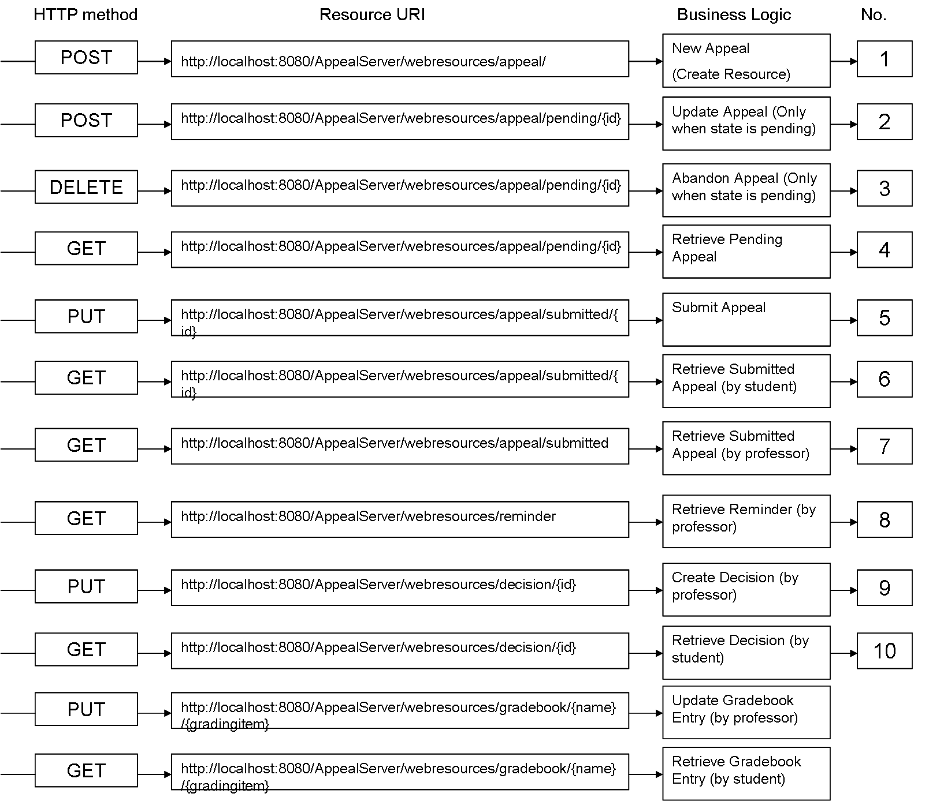

b. Resource transition diagram
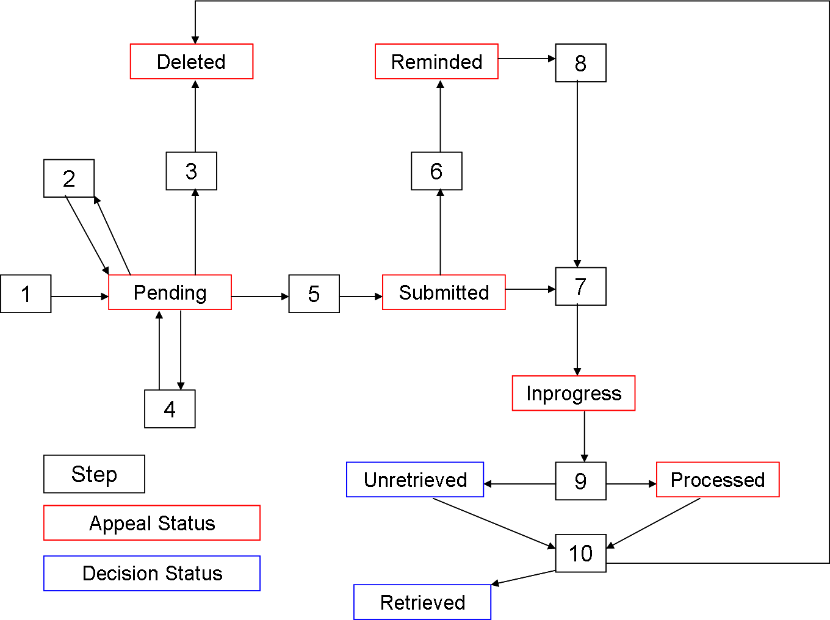

2. DAP
Media type: application/vnd-cse446-appeals+xml
Link relation values:
http://localhost:8080/AppealServer/webresources/relation/self, used to GET or retrieve appeal
http://localhost:8080/AppealServer/webresources/relation/update, used to POST or update appeal
http://localhost:8080/AppealServer/webresources/relation/delete, used to DELETE or delete appeal
http://localhost:8080/AppealServer/webresources/relation/submit, used to PUT or submit appeal, or create decision
http://localhost:8080/AppealServer/webresources/relation/create, used to POST or create appeal
http://localhost:8080/AppealServer/webresources/relation/decision, used to GET decision
http://localhost:8080/AppealServer/webresources/relation/updatedgrade, used to GET gradebook entry

3, 4
(1) Resource:
- AppealResource: contains pendingAppeal (can be updated and deleted, can’t be processed) and submittedAppeal (can be processed, can’t be updated or deleted by students). Appeals will be deleted after decisions are retrieved by student (status will be changed to deleted, but appeals are still kept in correponding repository).
URI:
http://localhost:8080/AppealServer/webresources/Appeal/Pending/{appealId}
http://localhost:8080/AppealServer/webresources/Appeal/Submitted/{appealId}
- GradebookResource: store students’ name and grade of each grading item of each student.
URI:
http://localhost:8080/AppealServer/webresources/GradeBook/{name}/{gradingitem}
- DecisionResource: store decisions or processing results of appeals.
URI:
http://localhost:8080/AppealServer/webresources/Decision/{appealId}
- ReminderResource: store reminders. Reminders will be removed after retrieved by professor.
http://localhost:8080/AppealServer/webresources/Reminder/{appealId}

(2) Model and Resource Representation
AppealRepresentations are stored in pendingRepository and submittedRepository respectively. The former one can be modified and deleted by the student, while the later cannot. Appeals are first stored in the pendingRepository. After submision, it will be also stored in the submittedRepository and waiting for prof to process.
<AppealRepresentation> //Used to represent appeal, appeal status and id
<Appeal> //Contains student name, appeal subject, grading item and multiple appeal items
<Name>…</Name>
<Subject>…</ Subject> //APPEAL - XXX
<GradingItem>…</ GradingItem>
<AppealItems>
<AppealItem>
<Justification>…</Justification>
<Image>…</Image>
</AppealItem>
…
…
</ AppealItems >
</Appeal>
<AppealStatus>…</AppealStatus>
<Id>…</Id>
<Links>
<Link rel=”…” href=”…” mediatype=”…” />
…
<Link rel=”…” href=”…” mediatype=”…” />
</Lins>
</ AppealRepresentation >

Decision is the processing result of appeal. If the prof thinks the appeal makes sense, he will approve the appeal and also typed in a new grade for this grading item for this student. Otherwise he will disapprove the appeal and grade will not be changed. After an appeal is processed, the decision representation will be sent back to the server and stored in the decision repository. Gradebook will be correspondingly changed according to the decision.
<DecisionRepresentation>
<Decision>
<Name>…</Name>
<Approval>…</ Approval >
<GradingItem>…</ GradingItem>
<Comment>…</Comment>
<Grade>…</Garde>
</ Decision >
< Decision Status>…</ Decision Status>
<Id>…</Id>
<Links>
<Link rel=”…” href=”…” mediatype=”…” />
…
<Link rel=”…” href=”…” mediatype=”…” />
</Lins>
</ DecisionRepresentation >

When student tries to retrieve a submitted or reminded but not processed appeal, a reminder will be generated by the server and stored in the reminder repository. When prof would like to process appeals, he will first check the reminder repository. All reminders in there will be retrieved and processed one by one. After that, the prof will go to retrieve submitted appeals in the submitted repository. He may process one or more submitted appeals.
<ReminderRepresentation> //Contains reminders to professor
<Reminders>
<Appeal>…</Appeal>
<Id>…</ Id >
<Message>…</ Message>
<Link>…</Link>
</Reminders>
</ ReminderRepresentation >

NameItemGrade is what stored in the GradebookRepository. When the student retrieve certain item in that repository, the corresponding NameItemGrade will be returned.
<NameItemGrade>
<Name>…</Name>
<GradingItem>…</ GradingItem >
<Grade>…</ Grade >
</ NameItemGrade >

